

**POSITIVE PAY SYSTEM FOR CHEQUE PRESENTED AT COUNTERS**

To safeguard our esteemed customers’ hard earned money against fraudulent transactions through cheuques, Central Bank of India has implemented cheque verification through Positive Pay System for Cheques presented at Branch Counters for payment through Cash, Transfer and remittance of fund via NEFT/RTGS/DD etc. - amount Rs.50,000/- and above w.e.f. 01.01.2023.

Under this process customers are advised to submit minimum information about Cheque issuance for amount Rs.50,000/- and above. Customers can furnish the cheque issuance intimation through channels like – Internet Banking/Mobile App/SMS/Branch Interface. The submitted details will be matched while payment of cheque.

***The same shall be mandatory w.e.f. 01.02.2023.***

For SMS Mode-

PPS request through SMS mode details as shown below to be sent to mobile number 8828419112

**PPS <space><Last four digit of account number><space><Cheque number (6digit)><space><Cheque date (DDMMYYYY) ><space> <Amount> <space><Payee Name>**

Application for Branch Mode and Screen of application made through Mobile Banking and Internet Banking is made available hereunder.

Link for [Application](Application%20Format_PPS.docx)



PPS Mobile Banking in “Request” Menu

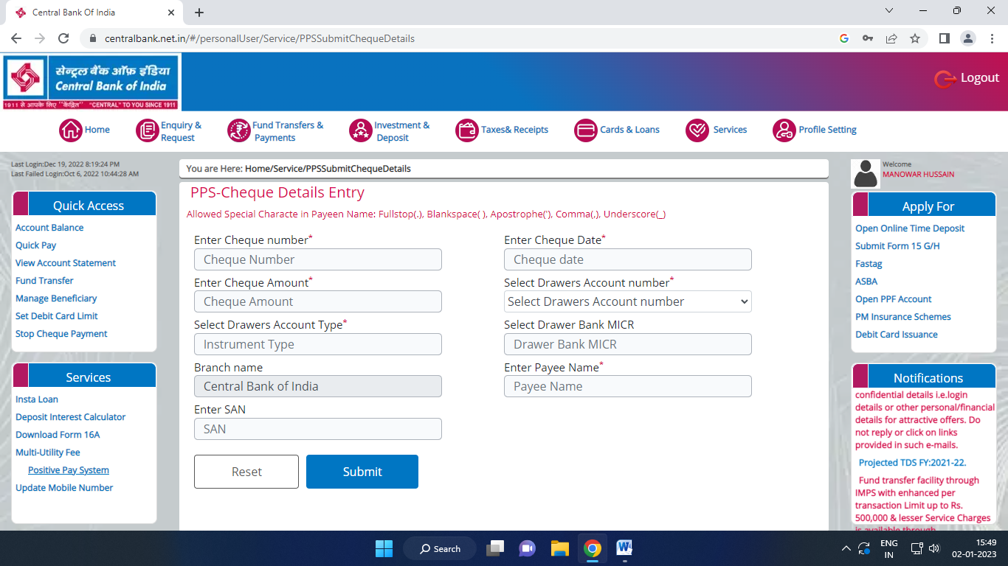

PPS Net Banking in “Services” Menu



**Branch_______________________________**

**POSITIVE PAY SYSTEM(PPS)**

**FORMAT FOR SUBMITTING INFORMATION BY CUSTOMER**

CHEQUE DETAILS :

|  |  |
| --- | --- |
| Cheque Number |  |
| Date of Cheque |  |
| Name of Beneficiary/Payee |  |
| Purpose of Cheque issuance |  |
| Amount of Cheque – In figure                                  – In Words | |  |  |  |  |  |  |  |  |  |  | | --- | --- | --- | --- | --- | --- | --- | --- | --- | --- | |  |  |  |  |  |  |  |  |  |  |   Rupees: |
| Account with Bank & Branch |  |

ACCOUNT HOLDER’S DETAILS :

|  |  |
| --- | --- |
| Name of Account Holder |  |
| Account Number & Branch | / |
| Account Type |  |
| MICR Code |  |
| PAN Number |  |
| MOBILE Number |  |

Date  :  
Branch :  
(where the details submitted)

                                                                                               Signature of A/C Holder   
                                                                                               (as in Bank’s Record)

PPS Data entered on ---------------- at ------AM/PM.

Employee no & Signature of Maker

Employee No & Signature of Checker

Acknowledgement

Received PPS details of Chq No ----------------------------- In the Ac Number ------------------------------------ of Mr/Ms/Mrs/M/S ---------------------------------------------- on --------------------at -------- AM/PM at our ----------------branch.

**(Incharge/Manager with seal)**



**KIND ATTENTION OF CUSTOMERS - POSITIVE PAY SYSTEM (PPS)**

As per RBI directives, **Positive Pay System** is implemented for cheques presented in clearing. Under this process customers are requested to submit minimum information about cheque issuance like- Account Number, Cheque Number, Amount, Date and Name of Beneficiary. Positive Pay System data has to be submitted through Channels like –SMS/Internet Banking/Mobile App/Branch Interface. The same is mandatory for amount Rs.5,00,000/- and above and optional for Rs.50,000/- to Rs.4,99,999/-. To avoid returning of cheques, all the customers issuing cheques Rs.5,00,000/- and above are requested to furnish PPS data before issuance of cheque.

For SMS Mode-

PPS request through SMS mode details as shown below to be sent to 8828419112

**PPS <space><Last four digit of account number><space><Cheque number (6digit)><space><Cheque date (DDMMYYYY) ><space><Amount><space><Payee Name>**