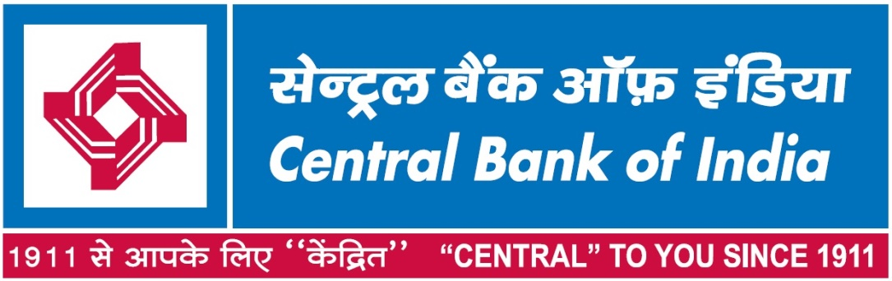

Tender No: RO/UPPA/GAD/CAR/01 DT:26/08/2023

**TENDER DOCUMENT**

**FOR**

**SALE OF BANK’S CAR**

**AT REGIONAL OFFICE,**

**Chandra Bhawan,Nehru Park,Jorhat,Upper Assam-785001**

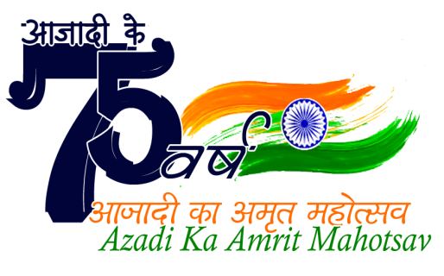

**NOTICE INVITING TENDER**

Tender No: RO/UPPA/BSD/2023-24/01 DT:26/08/2023

Central Bank of India, a body corporate constituted in India under the Banking Companies (Requisition and Transfer of Undertaking) Act 1970 having its Head Office at Chander Mukhi, Nariman Point, Mumbai - 400021 hereinafter called "Bank" invites offers from interested parties who intend to purchase **Bank’s Car at Regional Office Upper Assam,Jorhat,Chandra Bhawan,Nehru Park,Jorhat City &Dist,Assam State,Pin-785001.** whose details are as mentioned below, on “As Is Where Is” basis. For complete description of the sale details, please refer the tender document.

The detail of vehicle proposed to be sold is as follows:

|  |  |  |  |  |
| --- | --- | --- | --- | --- |
| **Reg. NO.** | **Make** | **Model** | **Fuel Type** | **Month & Year of Manufacture** |
| AS 03 H9317 | Tata Motors | Tata IndicaVista | Diesel | March’2012 |

Tendering shall be conducted in accordance with Open Tender procedures of the Bank. For general public, bids must be accompanied by Earnest Money Deposit (EMD) of Rs. 10,000/- and Cost of Tender Document of Rs. 500/- as Demand Draft in favour of Central Bank of India payable at Jorhat. For Staff and retired Staff members of the Bank, the bids must be accompanied by Earnest Money Deposit (EMD) of Rs. 5000/-. Cost of Tender Document is not applicable for Staff and retired Staff members. Any tender not accompanied with EMD (for General Public) and the Cost of Tender Document shall be rejected. Cost of tender is not returnable. Tender document can be obtained from the Office at below mentioned address, during working hours of the Office (10 AM to 5 PM) and can also be downloaded from our website [**www.centralbankofindia.co.in/en/active-tender**](http://www.centralbankofindia.co.in/en/active-tender)

Important Dates:

Date of commencement of tender 31 August 2023

Period for inspection of vehicle 31 August 2023 to 20 September 2023 during Bank’s working hours

Last Date and Time for submission of bids at

below address 20 September 2023 at 3:00 PM

Time and Date of Opening of bids 21 September 2023 at 3:30 PM

Tender offers will be opened as per the schedule mentioned above at the address mentioned below in the presence of the bidders’ representatives who choose to attend the opening of tender. Terms and conditions and format for submitting the tender offer are described in the tender document. Further “Addendum”(if any)shall be issued on Bank’s website only and bidder has to refer the same before final submission of the Tender.

The Bank is not bound to accept any particular tender received in response to this invitation and reserves the right to reject all tenders and cancel the tendering process at any time without any liability to any party whatsoever.

**Regional Head**

**Regional Office Upper Assam, Central Bank of India,**

**Chandra Bhawan,Nehru Park Road,Jorhat City &Dist,ASSAM-785001**

**Ph: 8453412163/7000037544 email:** [**gadupparo@centralbank.co.in**](mailto:gadupparo@centralbank.co.in)



Tender No: RO/UPPA/BSD/2023-24/01 DT:26/08/2023

**TENDER DOCUMENT FOR SALE OF BANK’S CAR AT REGIONAL OFFICE UPPER ASSAM, CHANDRA BHAWAN,NEHRU PARK ROAD,JORHAT CITY &DISTRICT, ASSAM 785001.**

1. Central Bank of India, a body corporate constituted in India under the Banking Companies (Requisition and Transfer of Undertaking) Act 1970 having its Head Office at Chander Mukhi, Nariman Point, Mumbai - 400021 hereinafter called "Bank" **invites offers from interested parties who intend to purchase Bank’s Car at Regional Office Upper Assam, Central Bank of India, Chandra Bhawan,Nehru Park Road,Jorhat City &Dist,Assam 785001.** whose details are as mentioned below, on “As Is Where Is” basis.

2. The detail of vehicle proposed to be sold is as follows:

|  |  |  |  |  |
| --- | --- | --- | --- | --- |
| **Reg. NO.** | **Make** | **Model** | **Fuel Type** | **Month & Year of Manufacture** |
| AS03H9317 | Tata Motors | Tata Indica VISTA | Diesel | March’2012 |

3. Tendering shall be conducted in accordance with Open Tender procedures of the Bank.

4. For general public, bids must be accompanied by Cost of Tender Document of Rs. 500/- as Demand Draft in favour of Central Bank of India payable at Jorhat. Cost of Tender Document is not applicable for the Staff and retired Staff members of the Bank. Any bid from General public not accompanied with the Cost of Tender Document shall be rejected. Cost of tender is not returnable.

5. For general public, bids must be accompanied by Earnest Money Deposit (EMD) of Rs. 10,000/- as Demand Draft in favour of Central Bank of India payable at Jorhat. For Staff and retired Staff members of the Bank, the bids must be accompanied by Earnest Money Deposit (EMD) of Rs. 5000/-. Bids without EMD will be rejected.

6. Tender document can be obtained from Security/GAD Department, Regional Office, Central Bank of India, Nehru Park Road, Chandra Bhawan,Joraht, Assam 785001 during working hours (10 AM to 5 PM) and can also be downloaded from our website [**www.centralbankofindia.co.in/en/active-tender**](http://www.centralbankofindia.co.in/en/active-tender)

7. The vehicle identified for sale may be inspected by prospective bidders with permission of Security Department/BSD from 31 August 2023 to 20 September 2023 during Bank’s working hours at our Regional Office Chennai Office Premise with address mentioned above.

8. The bid should be submitted in a sealed envelope with superscription “Bid for Purchase of Vehicle No. AS 03 H 9317”

9.The bid along with prescribed documents should be submitted before **3:00 PM on 20 September 2023 to Regional Office, Upper Assam, Nehru Park Road, Chandra Bhawan,Jorhat, Assam 785001**. Tender offers will be opened at 3:30 PM on 21 **September 2023(if the Date Holiday ,Next Working Day will be Open)** and at the address mentioned above in the presence of the bidders’ representatives who choose to attend.

10. The offer submitted should have a validity of 90 Days from the bid opening date.

11. The successful bidder has to pay the full amount for the vehicle less amount of EMD within seven working days from the date of receipt of intimation by means of DD in favour of Central Bank of India, payable at Jorhat. Failure to make payment of the full amount in time may result in forfeiture of the offer to purchase the vehicle as well as the EMD submitted.

12. In case of no response from H 1 bidder or if the H 1 bidder refuses to accept the vehicle due to any reason, the EMD shall be forfeited and offer will be extended to the H 2 bidder (H 2 to match the rate of H 1). Similar procedure shall be followed in respect of H3,H4 etc. as long as the Bank is able to get a price above the Reserve Price. **The Reserve Price is Rs. 26,500/-(Twenty Six Thousand Five Hundred Only)+GST.** **Vehicle shall not be disposed below the Reserve Price.**

13. The sold vehicle will be delivered only after the transfer of registration to the name of purchaser and his/her name is updated in the records of Registrar of Vehicles as the new owner and after verification of KYC documents of the purchaser by the Bank. Format for submission of Application is attached as Annexure A with this tender document. The Bidder must submit the documents required to be submitted along with the bid to avoid rejection of application.

14. The sold vehicle shall have to be removed by the successful bidder at his own expenses.

15. The successful bidder will be responsible for getting the Registration Certificate of the vehicle transferred in his name and at his cost expeditiously. Photo copy of the RC & related documents should be given to the Bank before taking possession of the vehicle.

16. Approval of sale offer is subject to Bank’s internal procedure and as such participating bidders have no right to claim interest on the Earnest Money deposited by them with the bid/quotation/sale offers.

17. The Bidder has to sign each page of all the offer papers being submitted.

18. Bank will be discharged from its liability from the date of sale of vehicle.

19. In case of any dispute, jurisdiction will be restricted to Upper Assam only.

20. For any query, you may contact GAD/BSD, Ph: 8453412163/7000037544, email: [gadupparo@centralbank.co.in](mailto:gadupparo@centralbank.co.in)

21. The Bank is not bound to accept any particular tender received in response to this invitation and reserves the right to reject all tenders and cancel the tendering process at any time without any liability to any party whatsoever.

22. Further “Addendum”(if any)shall be issued on Bank’s website only and bidder has to refer the same before final submission of the Tender.

**ANNEXURE-A**

**APPLICATION FORM FOR PURCHASE OF BANK’S VEHICLE**

From,

Name:

Address:

Tel No./Mobile No.

To,

Chief Manager

Regional Office, Upper Assam

Central Bank of India,

Nehru Park Road,

Chandra Bhawan,Joraht City & Dist.

Assam -785001.

Sir,

Sub: **Tender Bid for Purchase of Bank’s Vehicle**

REF: Your Tender No. Tender No: RO/UPPA/BSD/2023-24/01 DT:26/08/2023

I/We resident of .................................................................................................... have inspected the vehicle Regn No.AS 03 H9317 and would like to submit my best bid as under.

|  |  |  |  |  |  |  |
| --- | --- | --- | --- | --- | --- | --- |
| **Reg. NO.** | **Make** | **Model** | **Fuel Type** | **Month & Year of Manufacture** | **Reserve Price (Rs.)** | **Offer Price (Rs.)**  **Excluding GST** |
| AS 03 H 9317 | Tata Motors | Tata Indica Vista | Diesel | 03/2012 | 26,500/- |  |

GST @ 18% will be borne by the purchaser.

Vehicle shall not be disposed below the Reserve Price.

1. I/We am/are submitting herewith my/our:

a) Identity

b) Address proof

(Copy of Driving License/Aadhar card/PAN card/Passport /Election Card)

2. I/We am/are submitting herewith nonrefundable application fee of Rs. 500/- (not applicable to staff/retired staff of the Bank), by DD details are as under:

|  |  |  |  |
| --- | --- | --- | --- |
| DD No | Date | Bank/Branch | Amount |
|  |  |  |  |

3. I/We am/are submitting herewith Earnest Money Deposit Money of Rs. 10,000/- or 5,000/-(Staff/Ex-Staff whichever is applicable) each, by DD details are as under:

|  |  |  |  |
| --- | --- | --- | --- |
| DD No | Date | Bank/Branch | Amount |
|  |  |  |  |

4. If I/We are successful bidder for the above said vehicle, I/We undertake to pay the full amount within 7 days from the date of intimation.

5. I/We undertake to take immediate delivery of the said vehicle on me/us obtaining transfer of registration of vehicle in my/our name after making full payment.

6. I/We also undertake to transfer the vehicle in my/our name and pay all charges/expenses for such transfer/registration of the same.

7. If I/We fail to deposit the full amount within 7 days of intimation, Bank is within their right, to forfeit the amount of Earnest Money Deposit of Rs. 10,000/- or 5,000/-(whichever is applicable)

Thanking you,

Yours faithfully,

Signature:

Date:

Place: